**DAILY ONLINE ACTIVITIES SUMMARY**

|  |  |  |  |  |  |  |  |  |
| --- | --- | --- | --- | --- | --- | --- | --- | --- |
| **DATE:** | **11/07/2020** | | | | | **NAME:** | **NAIPUNYA VINOD NAIK** | |
| **Sem & Sec** | **IV SEM & A SECTION** | | | | | **USN:** | **4AL18CS050** | |
| **Online Test Summary** | | | | | | | | |
| **Subject** | | **NO INTERNALS CONDUCTED** | | | | | | |
| **Max. Marks** | | **-----------------** | | **Score** | | | **---------------** | |
| **Certification Course Summary** | | | | | | | | |
| **Course** | 1. **PYTHON PROGRAMMING WITH DATA SCIENCE** 2. **GOOGLE CLOUD PLATFORM BIG DATA AND MACHINE LEARNING FUNDAMENTALS** | | | | | | | |
| **Certificate Provider** | | | **1)UDEMY**  **2)COURSERA** | | **Duration** | | | 1. **15 HRS** 2. **2 WEEKS** |
| **Coding Challenges** | | | | | | | | |
| **Problem Statement: 1)** [**Write a Java program for Reversal algorithm for array rotation by 3**](https://github.com/orgs/alvas-education-foundation/teams/2nd-year/discussions/148)**.** | | | | | | | | |
| **Status: EXECUTED** | | | | | | | | |
| **Uploaded the report in Github** | | | | | **YES** | | | |
| **If yes Repository name** | | | | | <https://github.com/naipunya-naik/lockdown-coding/blob/master/JAVA%20CODING/reversal%20algorithm_11-07-2020.java> | | | |
| **Uploaded the report in slack** | | | | | **YES** | | | |

Online Test Details: (Attach the snapshot and briefly write the report for the same).

NO INTERNALS CONDUCTED

Certification Course Details: (Attach the snapshot and briefly write the report for the same).

1. CERTIFICATION COURSE NAME:- **PYTHON PROGRAMMING WITH DATA SCIENCE**

**TODAY I COMPLETED THIS CERTIFICATION COURSE.**

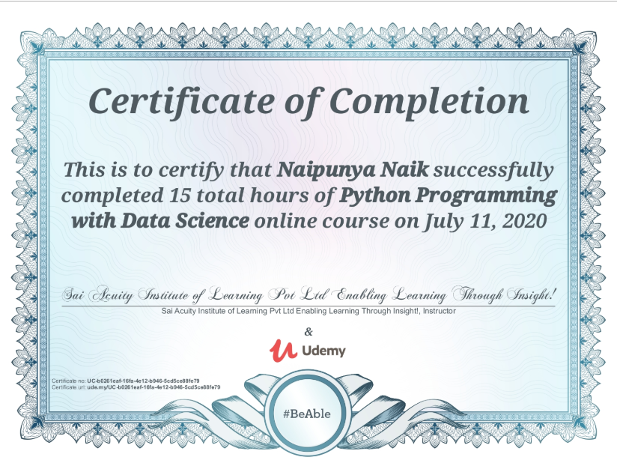

1. **CERTIFICATION COURSE NAME:-GOOGLE CLOUD PLATFORM BIG DATA AND MACHINE LEARNING FUNDAMENTALS**

* **TODAY , I STARTED A NEW COURSE ON COURSERA PLATFORM**

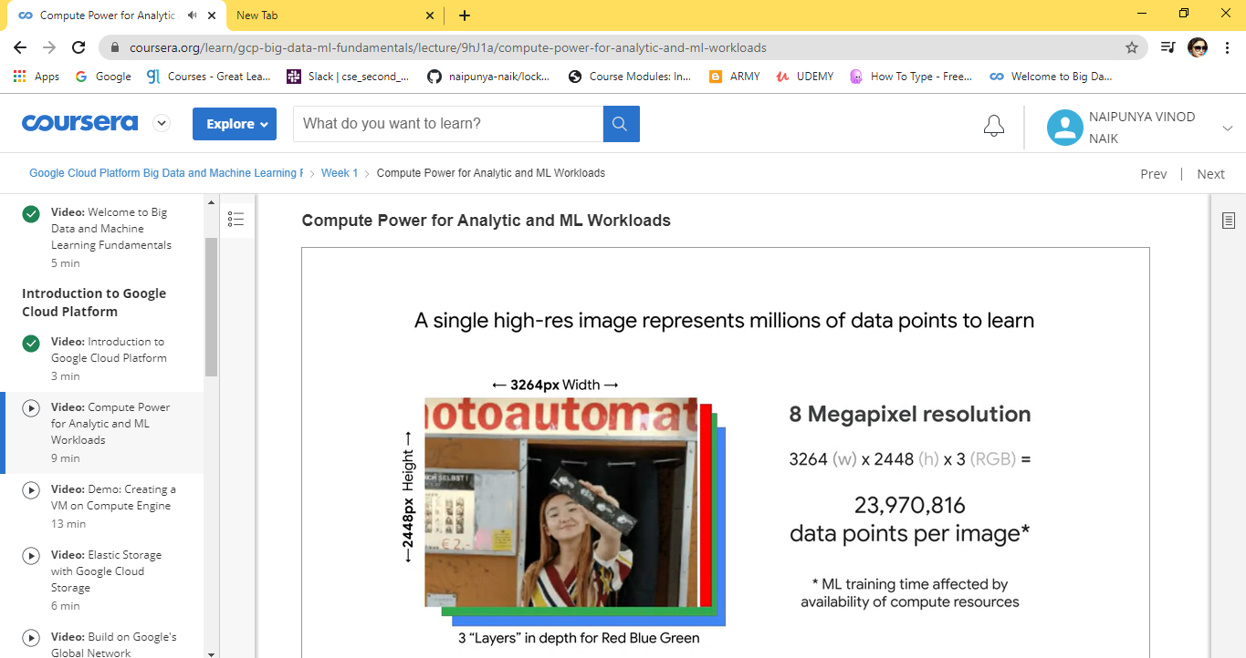

Coding Challenges Details: (Attach the snapshot and briefly write the report for the same).

PROBLEM STATEMENTS:- [Write a Java program for Reversal algorithm for array rotation by 3](https://github.com/orgs/alvas-education-foundation/teams/2nd-year/discussions/148).

Top of Form

Bottom of Form

|  |
| --- |
| Given an array a[], array size n and d the number of index to be rotated task is to write a function rotate(arr[],d,n) that rotates arr[] of size n by d elements.  Example Input: n= 6 arr[]= {1,2,3,4,5,6} d=3 (specific) Output: arr[]= {4,5,6,1,2,3} |

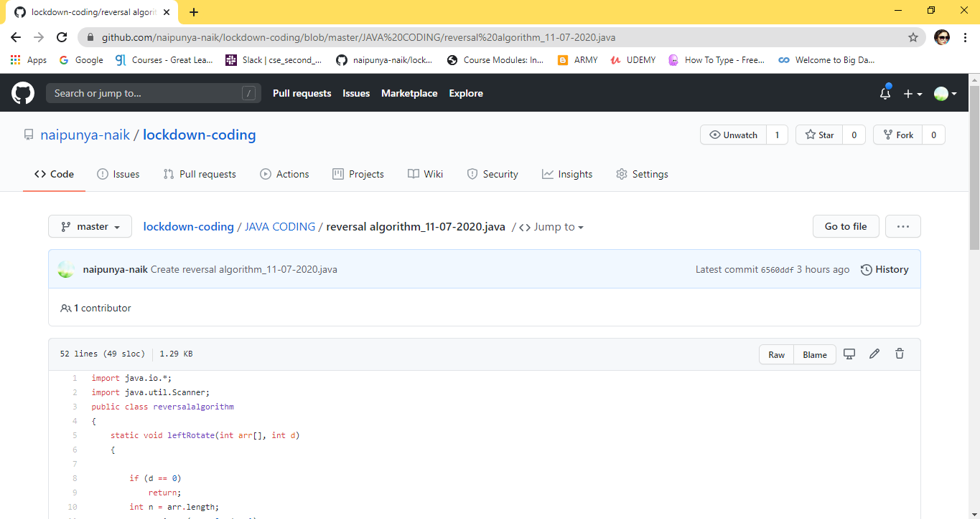

GITHUB REPOSITORY LINK:-

<https://github.com/naipunya-naik/lockdown-coding/blob/master/JAVA%20CODING/reversal%20algorithm_11-07-2020.java>